BIRMINGHAM NETBALL LEAGUE
(www.birmingham-netball.co.uk)

Safeguarding Statement – U16 Umpires

In line with England Netballs Safeguarding Young People in Netball Policy, ‘Enjoy, Ensure, Entrust’, the Birmingham Netball League (BNL) are fully committed to safeguarding young players and umpires within our League.

It is MANDATORY for all our Clubs to be England Netball Affiliated, and to provide the BNL with proof of this (as per Rule 2a) and therefore regulated and insured by England Netball, and committed to their policies and procedures.

Whilst the BNL itself is autonomous, and operates grass roots rules which may differ from County, Regional or International rules, our Member Clubs must remain aware of their safeguarding responsibilities:

Excerpt from EN Safeguarding Policy:

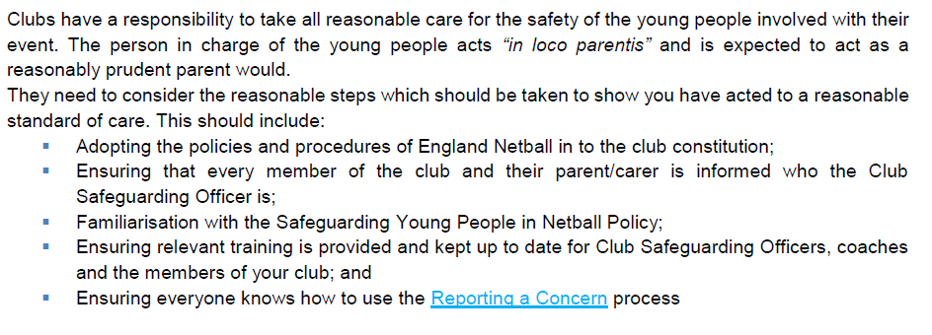
The BNL rule appertaining to Umpires states:

9b.All Umpires must hold at least an EN Into Officiating Umpiring Award. Umpires for division 1 to 2 MUST hold a minimum of an EN C Award, Divisions 3-4 at the discretion of the BNL Umpiring Secretary.
Member Clubs must be aware of their Safeguarding Responsibilities. The BNL would request Clubs make careful consideration before recommending any Under 16 Umpires apply to the BNL for umpiring placement, and that a Senior Club Member (or their County assigned Umpiring Mentor) is assigned to support and Mentor that person, and remain with them during their games. We will also consider the recommended placement levels for newly qualified umpires made by the County Umpiring Secretary.

We are committed to progressing our Officiators, supporting their CPD and do not wish to restrict their development through the levels of Officiating, especially where they have been Talent Identified to us, but we do wish to ensure and protect their safe participation.

Any concerns should be reported to the League Safeguarding Officer, Debbie Rolinson

